Newsletter
No. 5
June 2019
Erasmus + Strategic Partnerships
Improving communication, intercultural and social skills for foreigners and migrants who work as caregivers of elderly people in Europe
Project ID: 2017-1-RO01-KA202-037272

Meeting in Pescara , 1st -2nd of July 2019 |  | During the last meeting, the partners have analyzed the results of the MOOC piloting and established the measures to prepare the products of the project and publish them on the project website and EU platform, in order to optimise the value of the project results and maximise the potential of our activities, so that our project results to be used to the best possible advantage both within the partners’ organizations and beyond them. |  |  |  | 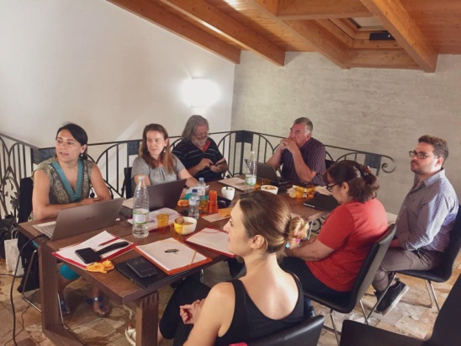
Results of the Massive Open Online Course (MOOC) |  | 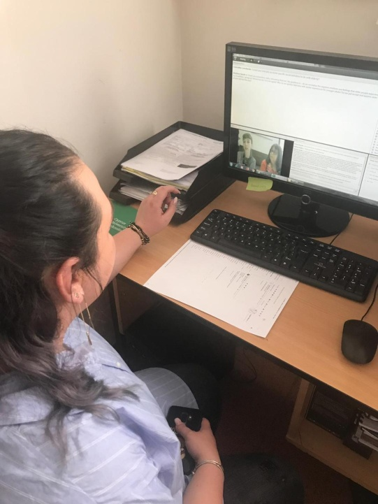 |  |  | The Massive Open Online Course (MOOC)  CULTURAL COMPETENCE TRAINING FOR CAREGIVERS OF OLDER PEOPLE  started on 6th of May 2019 and lasted for six weeks.  A number of 297 participants joined the MOOC on the Blackboard platform and 25 trainers and facilitators conducted the learning on the course and graded the participants.  The participants received the attendance certificates and got Course achievement badges, Group contribution badges or Leadership badges.
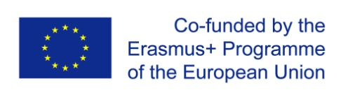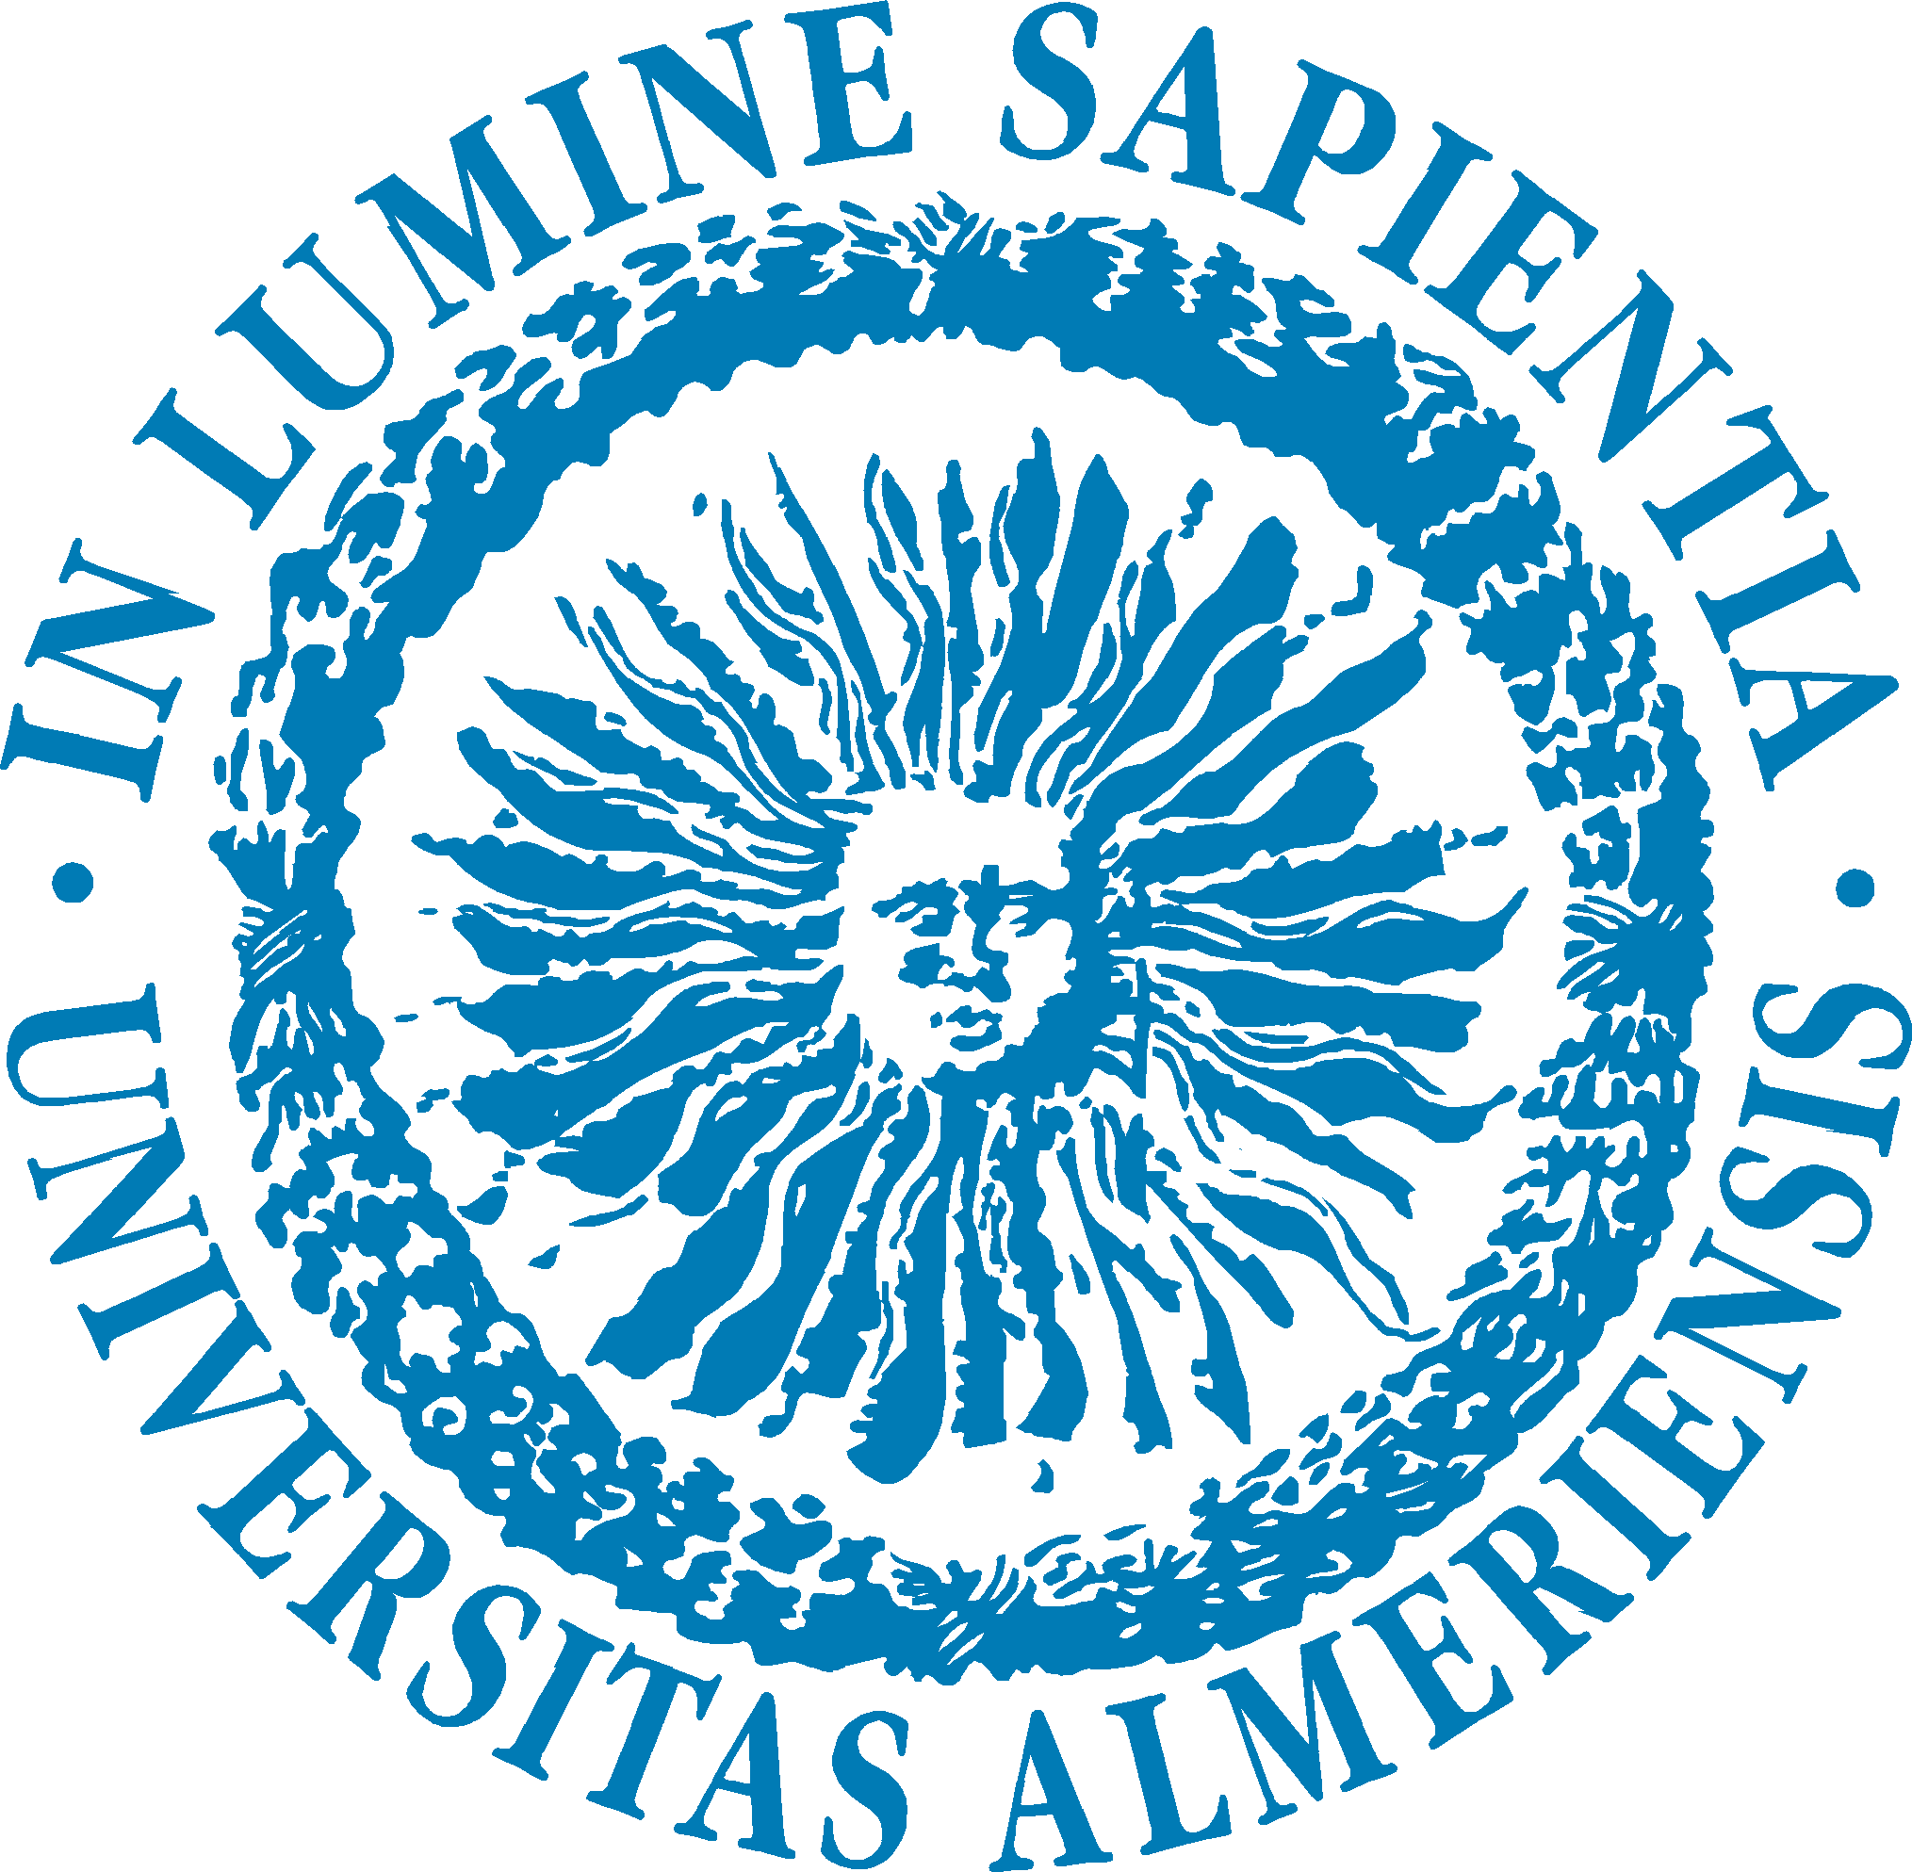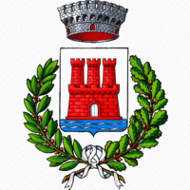

The main outputs of the IENE 7 project |  | The main outputs of the project are the Massive Open Online Course (MOOC) and a easy to navigate Course available on the project website.  The main project products can be downloaded by potential trainers from the project website www.iene7.eu and used to develop their own trainings:  - Training Model  - Curriculum  - Training/learning/evaluation resources  - Learning tools  On the project website the caregivers of older people may access to a easy to navigate Course in four languages (UK, IT, ES , RO).  The course may be also accessed through the IENE 7 App available in Google Play at https://play.google.com/store/apps/details?id=eu.iene7.httpsm.iene7 | 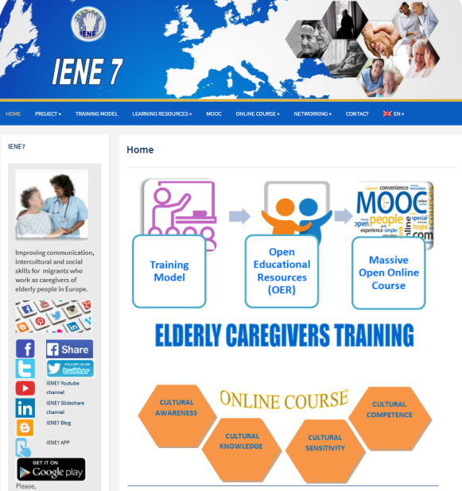  Using the IENE 7 model, resources and experience, trainers may use our innovative MOOC to set up their own MOOC.  On the MOOC section https://iene7.eu/mooc/, trainers may download our innovative MOOC model and resources :  - Kit for training the MOOC Facilitators  - Compendium of MOOC learning activities  - MOOC Best practice guide
Beyond of the IENE 7 project … |  |  |  | IENE 7  The partners designed a Valorization strategy and the Plan for dissemination and exploitation of project results after the project ends.  IENE 8 and IENE 9  The IENE 8 project “EMPOWERING MIGRANTS AND REFUGEE FAMILIES WITH PARENTING SKILLS”, expanding the existing Knowledge hub http://ienerefugeehub.eu/, created in IENE6  To continue the IENE initiative, a new project (IENE9) is planned to start In September 2019.
This project has been funded with support from the European Commission. This publication reflects the views only of the author, and the Commission cannot be held responsible for any use which may be made of the information contained therein. |  | 